**Saint Augustine’s College, Sydney**

**Software Engineering Year 11: Programming Fundamentals**

**Example Project Documentation: ‘HangPy’**

Table of Contents

Planning 3

Task Definition 3

Structure Chart 4

Algorithm Design 5

Flowchart 6

Data Dictionary 7

Implementation 8

GitHub Repository 8

Testing 9

Test Table 9

Release and Patch Notes 10

Release 1.0.0 10

Release 1.1.0 11

Release 1.1.1 11

Project Reflection 13

# Planning

## Task Definition – 20 MINS

I have been assigned the task of developing ‘HangPy’, a command-line driven Python application for the classic game of Hangman, ensuring an intuitive play that reflects the game's traditional essence. I aim to create a robust, bug-free application with a user-friendly and engaging command-line interface.

The functional requirements I will need to implement include:

Randomly select words from a predefined list at each game's start.

Display the initial game state with underscores marking the letters.

Capture player's letter guesses through a command line system.

Validate guesses and reveal correct letters within the word.

Track incorrect guesses, update the hangman figure, and conclude the game upon reaching guess limits.

Allow starting a new game once the current one concludes.

## Structure Chart – couple hours (draw.io)

As I will be taking a functional approach to the development of ‘HangPy’, it is appropriate to create a structure chart that will decompose the game logic into a mainline and the individual functions within, and help visualise the data/parameters that will be passed around.

The following flowchart maps out the functions within my program, a simple run down is here:

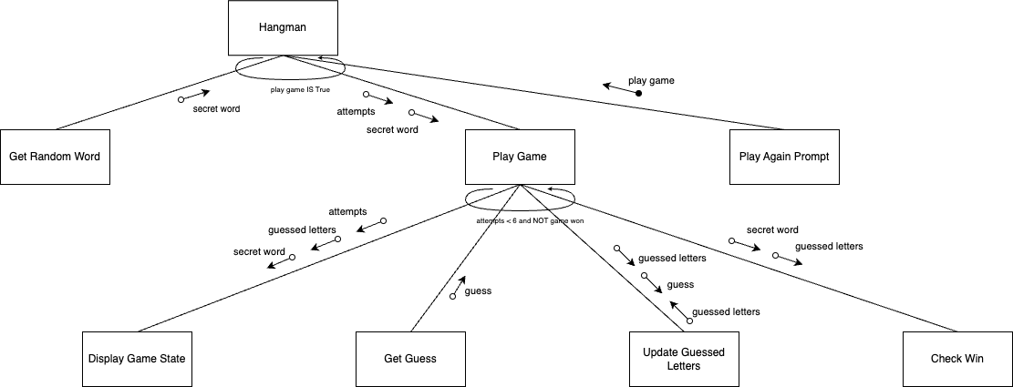

*This diagram was generated using* [*.drawio*](https://www.drawio.com/)*. It can be viewed as a template* [*here*](https://drive.google.com/file/d/1uzQsjF8thjtgjTTYEHFJa-khEq4BfrPz/view?usp=sharing)*.*

**Hangman** will be the top-level mainline that starts the game.

**Get Random Word** will be a function that selects a secret word for the game.

**Play Game** is the main game loop where the gameplay occurs, including getting guesses and updating the game state. It continues until the player runs out of attempts or guesses the word.

**Display Game State** will show the current status of the word being guessed and the remaining attempts.

**Get Guess**: This function simply gets a letter guess from the player.

**Update Guessed Letters** will be the function updates the set of letters that the player has guessed.

**Check Win** will determine whether the guessed letters match the secret word, indicating a win.

**Play Again Prompt**: After the game concludes, this prompts the player to start a new game or exit.

## Algorithm Design

The mainline logic of the 'HangPy' game proceeds as follows:

1. **Start**:
   * Start the game by initializing the list of words, the number of attempts, and other necessary game states.
2. **Gameplay**:
   * Select a secret word using the Get Random Word function.
   * Begin the main game loop which continues until the player guesses the word or runs out of attempts.
     + **Game Loop**:
       - Display the current game state using the Display Game State function.
       - Capture the player's guess with the Get Player Guess function.
       - If the guess is new, use the Update Guessed Letters function to add it to the list of guessed letters.
       - Decrement attempts if the guess is incorrect.
       - Determine if the player has won with the Check Win function.
3. **Win/Loss Screen and Replay**:
   * Once out of the loop, display a win or loss message.
   * Prompt the player to play again using the Play Again Prompt function.
     + If the player chooses to replay, reset the game variables and restart the game.
     + End the game if the player decides not to continue.

## Flowchart (draw.io)(used for explaining logic not the functions)(remember that assigning a variable counts as its own function block)(not extensive just a simple loop

This algorithm's logic can be effectively illustrated through a flowchart to visually augment comprehension. While the detailed operations of the subfunctions are simplified, this overview should adequately convey the workings of the HangPy game.

*This diagram was generated using* [*.drawio*](https://www.drawio.com/)*.*

## Data Dictionary (do at the end)

|  |  |  |  |  |  |
| --- | --- | --- | --- | --- | --- |
| Variable | Data Type | Format for display | Description | Example | Validation |
| word_list | List[String] | List of strings | List of potential secret words for the game | ["apple", "banana"] | Must not be empty |
| secret_word | String | Text | The word to be guessed by the player | "apple" | Must be from word_list |
| guessed_letters | Set[Char] | Set of characters | The set of letters that have been guessed | {'a', 'e'} | Unique characters only |
| attempts | Integer | Numeric | Number of attempts left for incorrect guesses | 6 | 0 to max number of attempts |
| game_won | Boolean | True/False | Flag to determine if the game has been won | True/False | True or False only |
| guess | Char | Single character | Current letter guessed by the player | 'a' | Single character |

# Implementation

## GitHub Repository

<https://github.com/fong-a/11-SE-Assessmnent-1-Examplar>

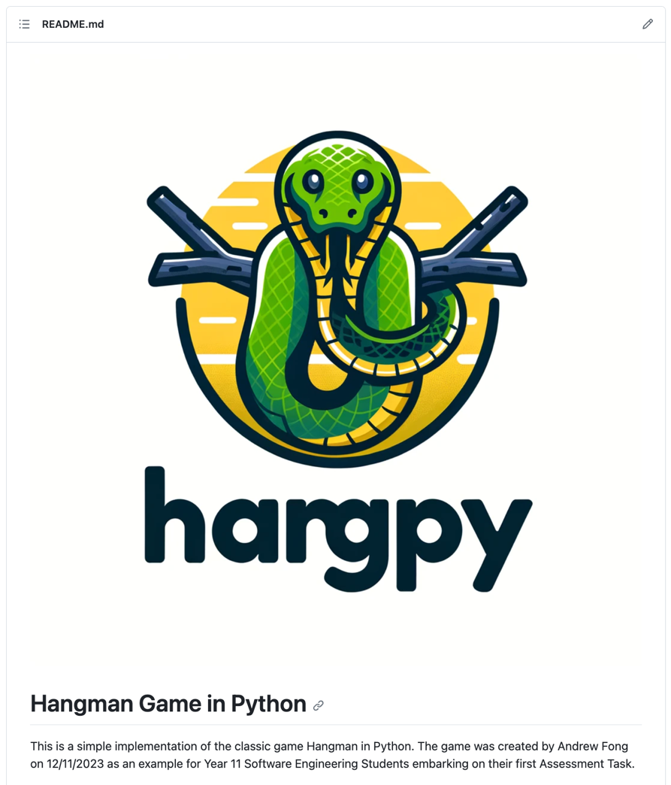

*This GitHub README.md was created using* [*https://readme.so/*](https://readme.so/)

# Testing

## Test Table

|  |  |  |  |  |  |  |
| --- | --- | --- | --- | --- | --- | --- |
| Test ID | Category | Test Case Description | Input to Provide | Expected Output | Actual Output | Pass/Fail |
| Test 1 | Path Coverage | Verify attempts increment on multiple failures | An incorrect letter six times | Attempts counter reaches 6 and game ends | “You Lost”  “Play Again (Y/N): ” | Pass |
| Test 2 | Boundary Value | Check behavior on last attempt | Correct letter after 5 incorrect guesses | Game indicates a win condition | “You Lost”  “Play Again (Y/N): ” | Pass |
| Test 3 | Path Coverage | Validate win condition with minimum guesses | Correct letters of the word in order | Game should indicate win before max attempts | “You Lost”  “Play Again (Y/N): ” | Pass |
| Test 4 | Faulty Data | Input non-alphabetic characters as guess | '1', '@', '-' | Game should prompt for correct input format | Game rejected invalid characters and prompted for letters | Fail |
| Test 5 | Abnormal Data | Enter an already guessed letter | Correct letter guessed twice | Game notifies letter was already guessed | “You already guessed that letter!  Guess a letter:” | Pass |
| Test 6 | Path Coverage / Replayability | Check game restart functionality | 'y' after game concludes | Game restarts with initial conditions | Game restarted with initial conditions as expected | Pass |
| Test 7 | Boundary Value | Attempt to start game with invalid difficulty | '0', then '4' for difficulty level | Game prompts for valid difficulty input | “Invalid input. Please enter 1, 2, or 3.  Select a difficulty level (1, 2, or 3): 1” | Pass |

# Release and Patch Notes

## Release 1.0.0

<https://github.com/fong-a/11-SE-Assessmnent-1-Examplar/releases>

## Release 1.1.0

<https://github.com/fong-a/11-SE-Assessmnent-1-Examplar/releases/tag/v1.1.0-difficulty-mode>

Patch 1.1.0 is a feature update, whereby I introduced different game difficulties, The game now prompts the user to select a difficulty level at the start of the game and will keep prompting them until they enter a valid input. It then selects a word from the appropriate list based on the chosen difficulty level. I have implemented the new words using a dictionary, rather than a simple array of strings.

## Release 1.1.1

<https://github.com/fong-a/11-SE-Assessmnent-1-Examplar/releases/tag/v1.1.1-difficulty-modes>

I noticed after adding the difficulty modes, there was a new bug whereby I had introduced a run-time error. I fixed this bug, and fixed the issue picked up in Test 4, to properly validate player guesses.

|  |  |  |  |  |  |  |
| --- | --- | --- | --- | --- | --- | --- |
| **Test 4** | Faulty Data | Input non-alphabetic characters as guess | '1', '@', '-' | Game should prompt for correct input format | Game rejected invalid characters and prompted for letters | Fail |

# Project Reflection

The planning phase of the algorithms, albeit initially met with skepticism due to my preference for direct coding, taught me the value of a structured approach. Although it extended the time required to accomplish tasks, it ensured the achievement of the set objectives with greater precision.

Initially, I encountered difficulties with array manipulation, particularly with iterating through them. Over time, familiarity with the indexing system grew, simplifying the process.

The GitHub repository management proved to be a rewarding aspect of the project, particularly with the utilization of readme.io, which facilitated efficient documentation formatting. The culmination of development efforts into the initial v1.0 release was a gratifying milestone.

The creation of the testing table was a pivotal moment, underscoring the critical nature of thorough testing. It brought to light a significant, overlooked bug that could have undermined the entire game.

My proficiency in Python has advanced considerably through this first project. I have mastered the structure of a basic game loop and the method of breaking down complex problems into manageable segments. With an understanding of object-oriented programming principles, I am looking forward to exploring beyond the confines of a functional approach next term.